VySkan
Product Name | Smart Logistics Electronic Seal
Product Model | VK15-ESL

Real-Time Tracking. Full Protection. Built to Last.
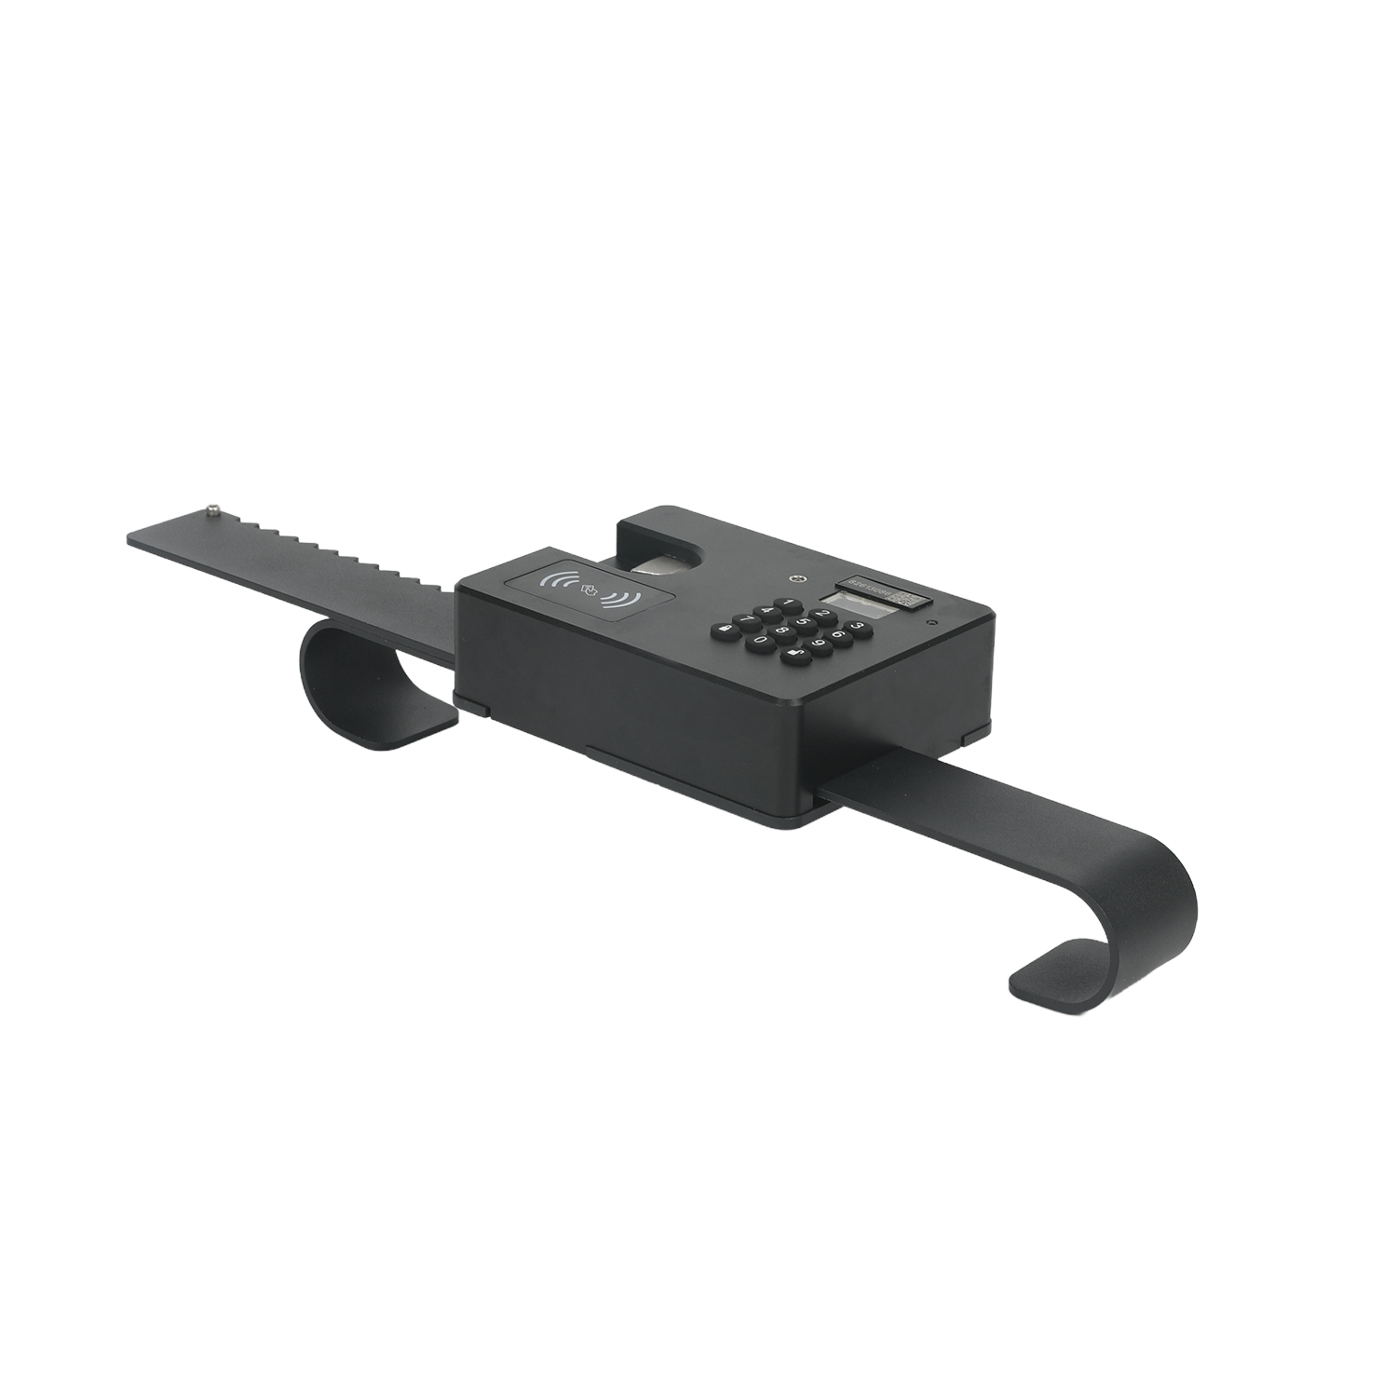

The Vyskan VK15-ESL Logistics Electronic Seal is an advanced high-tech product designed for real-time monitoring of cargo in transit. Combining proprietary micro-electromechanical control technology with 4G wireless communication, it provides end-to-end security for containerized cargo transportation. Equipped with door detection sensors that instantly detect and alert on unauthorized door removal, it is ideal for cargo supervision and in-transit security monitoring, fully replacing traditional mechanical seals for intelligent, traceable logistics security management.

1. Core Value
➢ 4G Real-Time Tracking & Remote Control: Featuring 4G/SMS wireless communication for real-time location tracking throughout the journey. Supports remote seal and unlock commands from the management platform, enabling fully visualized cross-regional logistics supervision.
➢ Multi-Layer Security & Smart Alarms: Patented door status detection technology instantly alerts the platform if the shackle/body is tampered with or container doors are removed. One-time password mechanism ensures unique and controllable unlock authorization.
➢ Industrial-Grade Durability & Extended Endurance: IP67 protection rating with fully sealed explosion-proof design for harsh outdoor environments. 10AH high-capacity lithium polymer battery delivers up to 15 days of continuous operation for long-haul transportation.

2. Target Applications
➢ Container Logistics Monitoring: (Suitable for full-journey security monitoring of road and rail container transport, real-time location and status tracking, preventing unauthorized opening and cargo tampering).
➢ Hazardous & High-Value Cargo Transport: (Fully sealed explosion-proof design for hazardous cargo environments, real-time alarm mechanism ensuring in-transit security of high-value goods).
➢ Customs & Bonded Zone Supervision: (Supports remote backend authorization control, one-time password verification meets strict compliance requirements for customs supervision and bonded logistics).

3. Technical Specifications

3.1 Cellular & Positioning
Category | Specification | Description
Communication | 4G / SMS | Wide-area wireless communication for remote data transmission and command delivery.
Antenna | Built-in Omni-Directional | Integrated internal design for stable signal and tamper resistance.
Control Mode | Remote Platform / Keypad Password | Dual control modes: platform remote command and local one-time password.

3.2 Power & Electrical
Category | Specification | Description
Battery Type | 10AH Lithium Polymer | Ultra-high capacity lithium battery, hermetically sealed inside the lock body.
Operating Voltage | 3.7V ~ 4.2V | Standard lithium battery operating voltage range.
Avg. Current | 100mA | Optimized low-power circuit design.
Charging | Magnetic Charging Dock | Magnetic charging design preserves waterproof integrity.
Charge Time | About 6-7 Hours | 2A high-current charging, requires dedicated manufacturer charger.
Battery Life | ~15 days / ~12 days | ~15 days at hourly upload; ~12 days at 30s upload (2 daily operations).

3.3 Functions & Alarms
Category | Specification | Description
Door Detection | Patented Status Detection | Real-time door status monitoring against unauthorized access.
Unlock Method | One-Time Dynamic Password | Unique one-time password per unlock for maximum security.
Alarm Functions | Tamper Alarm / Door Breach Alarm | Instant platform alert on shackle/body damage or door removal.
Data Logging | Non-Volatile Memory | Large-capacity storage with detailed operation logs.
Status Display | LCD Screen | Clear visual indication of battery, signal, positioning and working status.
Emergency Power | Power Bank Charging | Emergency charging via power bank when battery is depleted.

3.4 Physical & Environmental
Category | Specification | Description
Dimensions | 420mm × 90mm × 60mm | Integrated bar-lock design for container door mounting.
Locking Range | 24 ~ 46 cm | Adjustable locking range for various door specifications.
Weight | About 1000g | High-strength construction for solid durability.
IP Rating | IP67 | Premium dustproof and waterproof for harsh outdoor conditions.
Service Life | 5+ Years | Industrial-grade design lifespan, reusable and recyclable.
Explosion-Proof | Fully Sealed Body | Hermetically sealed structure suitable for hazardous environments.

3.5 LCD Indicator
Icon | Status Description
Network Signal | Current cellular signal strength
Transmitting | Data upload or command communication in progress
Positioned | GPS positioning successful
Battery Level | Current remaining battery capacity
Low Battery | Battery low, charging required
Open Alarm | Door opening or tamper alarm triggered
Locked | Seal is engaged and locked
Ready to Unlock | Verification passed, unlock available

4. Deployment & Operation
Operation Flow:
1. Sealing: After loading, the driver pulls the movable arm over container posts, tightens the locking bar, and long-presses the "Lock" button for local sealing. The backend can also issue seal commands with a system password overriding the local password.
2. In-Transit Monitoring: Once sealed, the lock cannot be opened locally. The device automatically uploads location and status at set intervals, triggering immediate alarms upon unauthorized opening or tampering.
3. Unsealing: Upon arrival, the consignee enters the last 6 digits of the platform seal password for local unlock, or the management platform issues a remote unlock command.

5. Usage & Precautions
1. Avoid prolonged exposure to extreme temperatures, high humidity, or highly corrosive environments. Custom low-temperature battery required below -20℃;
2. Charge promptly when voltage drops below 3.7V to avoid mid-journey depletion. If battery is drained, emergency charge with a power bank for ~5 minutes to resume operation;
3. Always use the manufacturer's dedicated charger and magnetic charging cable. Do not substitute with other USB power sources. Keep the lock open while charging for full capacity;
4. When locking, secure the movable arm around container posts and tighten the bar. Once sealed, manual opening is impossible. Press the release button after unlock to remove the arm;
5. SIM card is pre-installed inside the lock body and is not user-replaceable. Battery charge/discharge cycle life is approximately 1000 cycles.

Environmental Specifications
• Operating Temperature: -20℃ ~ +60℃ (custom low-temp battery below -20℃)
• Relative Humidity: ≤ 90% RH
• Atmospheric Pressure: 86KPa ~ 106KPa
• Protection Rating: IP67

Standard Package Contents
• Logistics Electronic Seal × 1
• Dedicated Charging Cable/Charger × 1
• Product Certificate × 1

6. A Personalized Service Prepared For You
➢ 1× VK15-ESL Sample Device (Pre-configured)
➢ Full API & Platform Integration Documentation
➢ 1-on-1 Technical Support from our Field Engineers

7. Contact Us
Website: https://vyskan.com/
Email: marketing@vyskan.com

